 **Customer Contracts Functional Specifications**

**Revenue and Billing Plan Templates (Set ID: SHARE, UNU specific templates)**

**Navigation: Set up Financials/Supply Chain>Product- Related>Contracts>Templates> Bill Plan Detail Templates:**

|  |  |  |
| --- | --- | --- |
| Contract Type | Milestone Description | Milestone Conditions |
| CORE | AR PAID | Cash is Received |
| NON CORE | Donor Agreement Signed/CshPaid | Donor Agreement Signed |
|  |  | First Deposit Received |
|  | Interim Certified Fin.Statemnt | ICFS Submitted |
|  |  | ICFS Due |
|  | Interim Certified Fin.Statemnt | ICFS Submitted |
|  |  | ICFS Due |
|  | Final Certified Fin.Statement | FCFS Submitted |
| NON CORE NON STANDARD | Donor Agreement Signed/CshPaid | Donor Agreement Signed |
|  |  | First Deposit Received |
|  | Date |  |
|  | Date |  |
|  | Date |  |
| NON CORE EC | Donor Agreement Signed | Donor Agreement Signed |
|  | Parliamentary Approval | Parliamentary Approval |
| CORE | Date Met | Date Met |
|  | Date Met | Date Met |

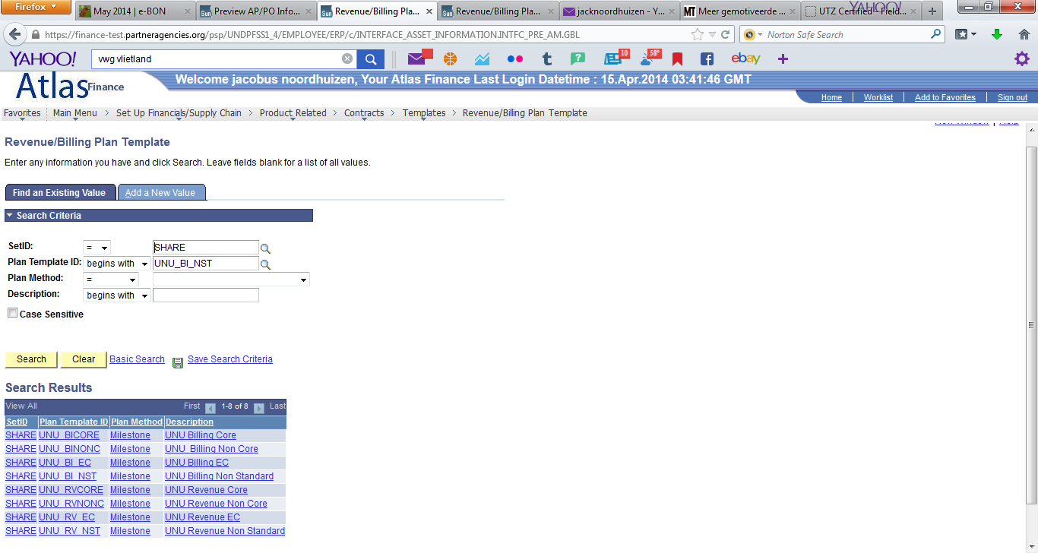

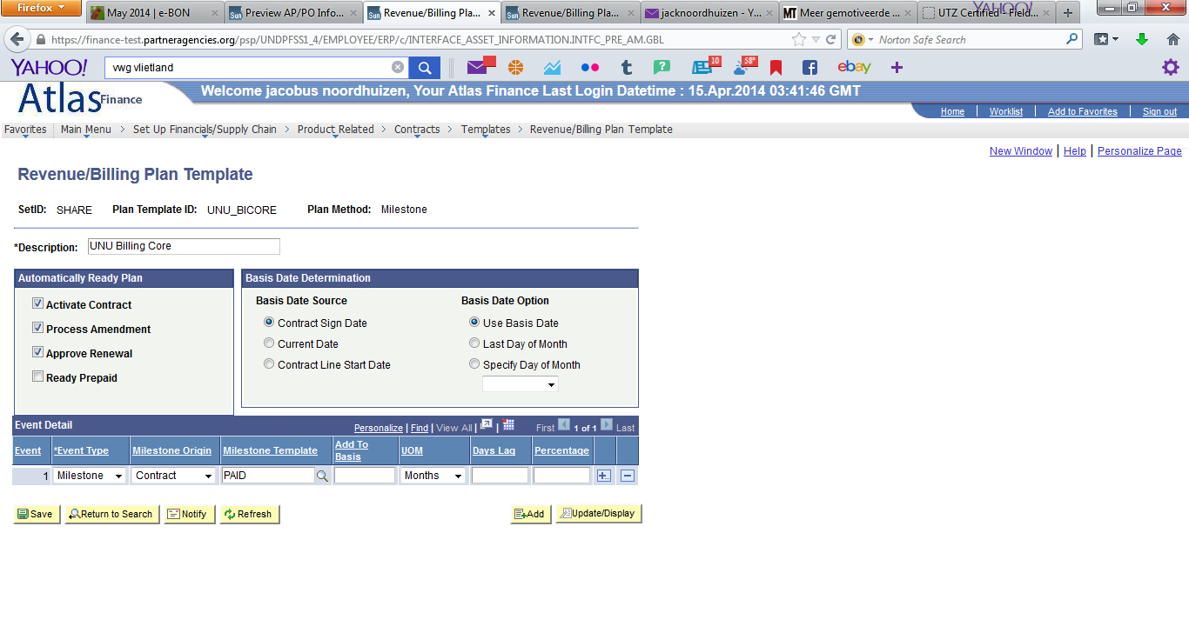

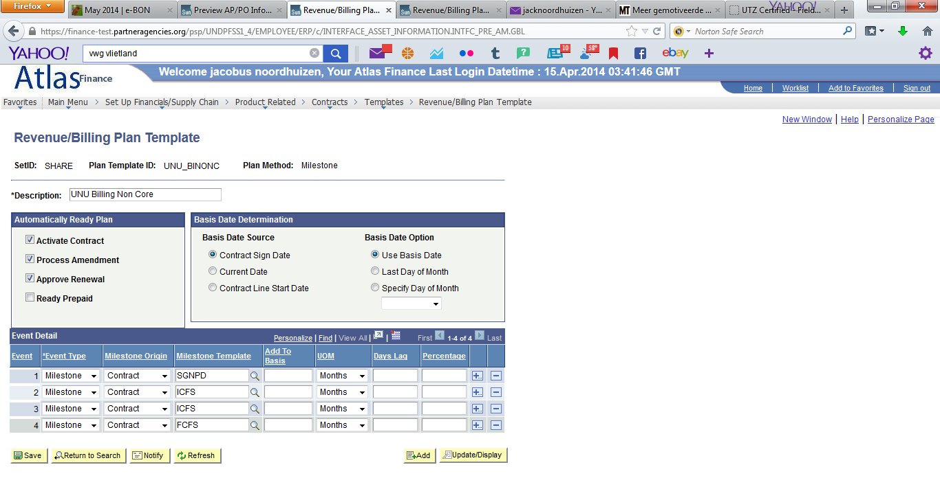

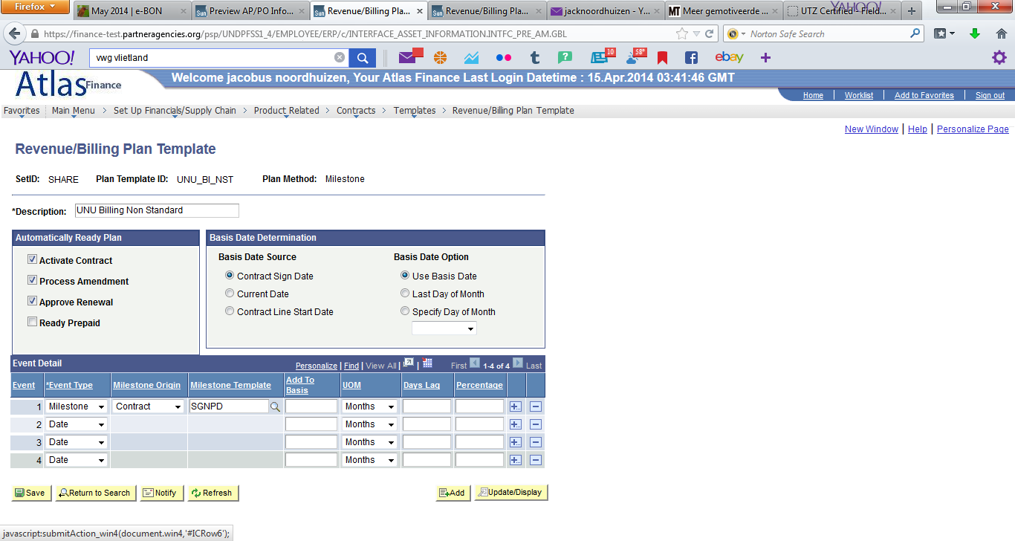

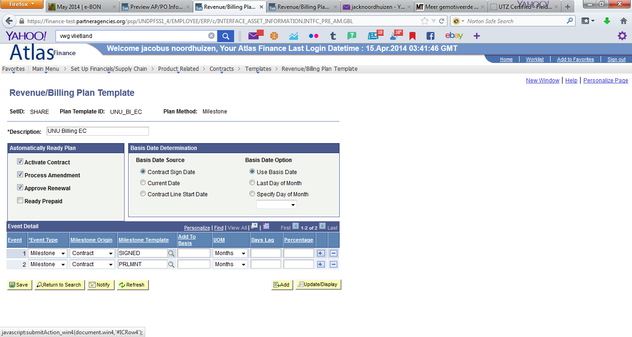

**New Billing Plan Template: UNU Billing Core Date**

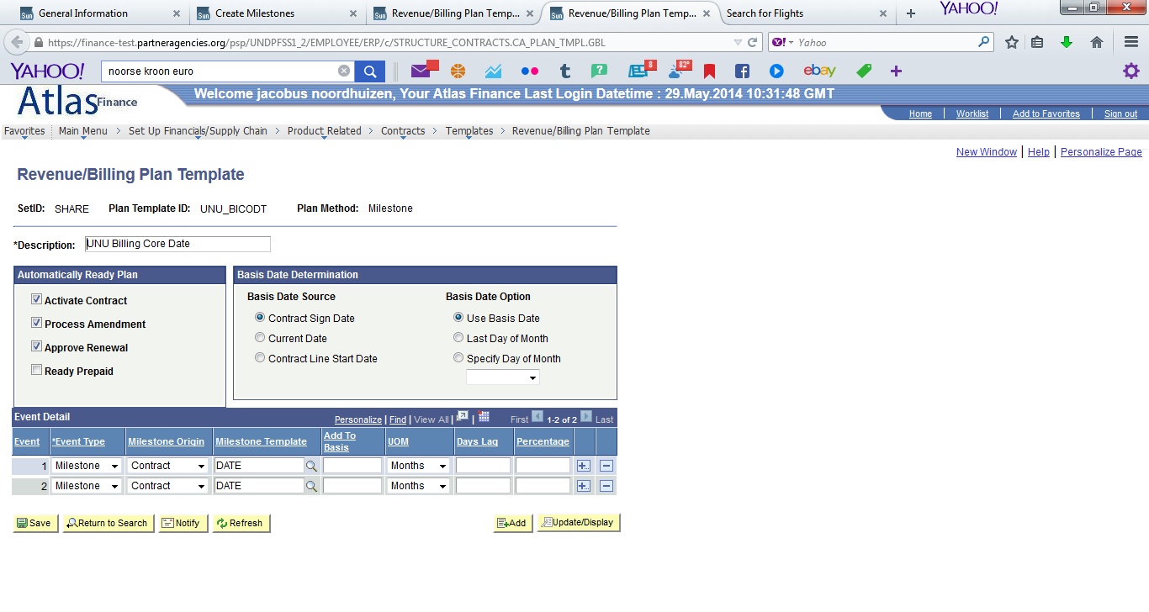

**New Revenue Plan Template: UNU Revenue Core Date**

